There is no statistically significant difference in risk-adjusted returns between ETFs tracking high-risk and low-risk country indices.
Growing up in Cambodia, I frequently noticed a large dissonance between how media reported on both Cambodian politics and the economy compared to what was actually happening. Large, potentially groundbreaking events wouldn’t even become international news. As a result, when following certain stocks such as 3918.HK, I wondered how much less efficient the market would be with far less information to work with and to what degree risk was accurately reflected. As a result, I wanted to learn more about how risk is reflected so I am experimenting with the null hypothesis “There is no statistically significant difference in risk-adjusted returns between ETFs tracking high-risk and low-risk country indices.”
Using Sharpe Ratio and Sortino Ratio to look at risk adjusted returns.
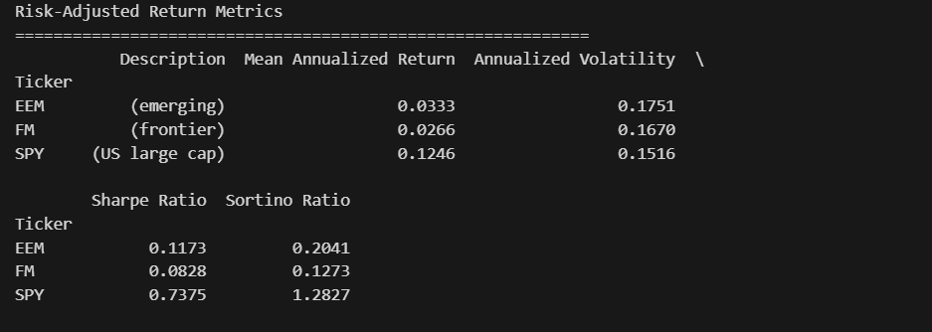
If we focus on the Sharpe Ratio and Sortino Ratio over this short period it does in isolation, suggest that there is economically meaningful difference between 2013-2023 and that Index Funds focusing on higher risk countries have far better risk adjusted returns but this is not enough to reject our hypothesis for many reasons. First, this is an incredibly short period and is based on point estimates which doesn’t establish a statistically significant divergence in risk-adjusted returns. Second, it doesn’t account for structural differences between the different funds such as market cap of the companies contained within the funds or the industry of business population the funds.
